Spike 1: Markup

Accessibility

Who does semantic HTML benefit?
- Benefits both users and developers
- Gives users information about the semantics of a webpage (i.e. what things are rather than what their style or content is)
- Can be interpreted by assistive technologies such as screen readers
- Aids keyboard navigation and document summary (e.g. headings can be turned into a “skeleton” of the page that users can navigate using hot keys)
- For developers, it helps to make the code more organised and more readable which in turn makes it easier to maintain.
- Built-in browser rendering of some semantic elements (e.g. select input type)

How does ARIA relate to HTML?
- ARIA (Accessible Rich Internet Applications) attributes provide additional information about the purpose and behaviour of elements
- Can be used by assistive technologies such as screen readers to provide useful information to users.
- Some ARIA attributes mirror HTML whereas others provide semantics that do not natively exist in HTML.
- Attributes don’t change behaviour/functionality.

What’s the difference between accessible and inclusive?
- Accessibility refers to the design of webpages so that they can be accessed by by people with disabilities (e.g. sight-impaired users or those with ADHD)
- Inclusion refers to creating an environment in which all users feel welcomed, respected, and valued, regardless of their differences.

CSS architecture

Why are CSS naming conventions useful?
A good naming convention will tell you...
- what type of thing a class does
- where a class can be used
- what (else) a class might be related to
This in turn makes it more readable and maintainable so that developers can understand and navigate the code more quickly and easily.

When might specificity become a problem?
- Rulesets should be scoped using as low specificity as is reasonably possible
- Overly specific selectors can be very difficult and time-consuming to undo later on

How can composition help us build UIs?
- Helps us to build reusable components which are easier to maintain and avoid unnecessary complexity and development time
- Components can themselves be composed into larger components
- Allows for better separation of concerns which makes it easier to change one part of a UI without affecting another

CSS layout

What is the box model?
The CSS box model is a box that wraps around every HTML element:
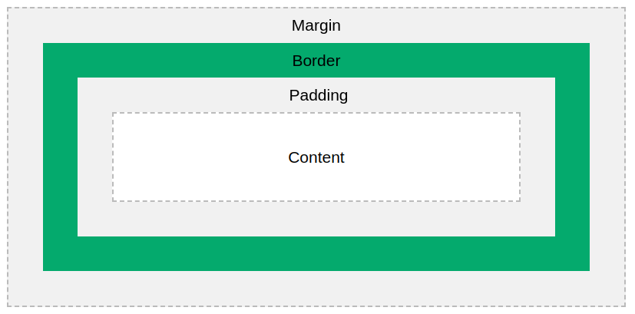

How does the display property affect layout?
- Specifies the display behaviour (the type of rendering box) of an element.
- e.g. ‘inline’, ‘block’, ‘flex’, ‘grid’, ‘none’...

How does the position property affect layout?
- Sets how an element is positioned within a document
- static: the normal flow of the document.
- relative: it's similar to static, but now we get the freedom to offset the position relative to itself.
- absolute: takes the elements out of the regular flow of the document.
- fixed: behaves the same as absolute, but now no space is created for the element in the document layout.
- sticky: element is positioned according to the document's normal flow, but it offsets relative to its nearest scrolling ancestor.

Responsive design

What CSS units should we use for dimensions?
The units em, rem, ch, and ex are more suited to ensuring a site remains accessible because they are all units relative to the user’s default font size, as set in their operating system and/or browser. Using px should be avoided as the user’s browser will ignore their preferred settings forcing them to zoom in.

What are absolute and relative units?
Absolute units are fixed in size and relate to a measurement (for example pixels). They will not scale when some other (parent) unit is changed. Relative units are determined by the size of a parent element are more suited to accessible and responsive layouts.

When should you use a media query? Are they only for screen size?
Media queries allow you to apply CSS styles depending on a device's general type or other characteristics such as screen resolution or browser viewport width. They are not only for screen size – for example they can be used to identify whether styles are for print or screen.

How can mobile-first CSS make responsive styling easier?
A mobile-first approach to site design is generally more efficient than desktop-first because it enables you to use default browser layouts more easily. Starting with the simplest layout and adding complexity with screen size makes sense because you generally want larger viewports to contain more complex layouts.

